Technical Documentation

- Describe the project.
This project is a web app, that helps users to organize their TODO tasks. Users can add / remove tasks and keep track which tasks have been done or not yet.

The app use localStorage to store data of the app, so that users don't loose their saved tasks
even after closing the app.

- How to use the app.
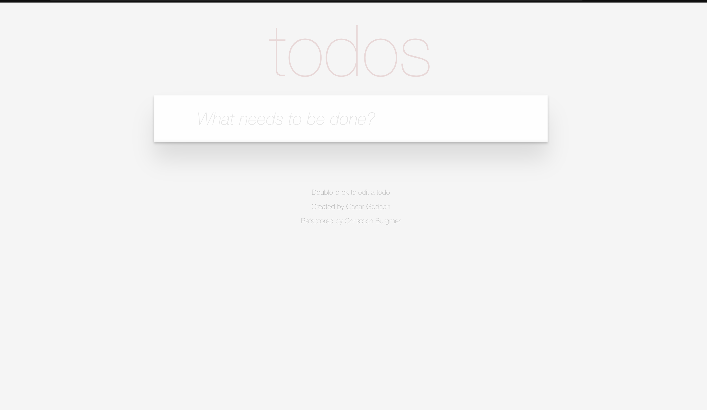
Figure 1. How the App looks like when one user first start the app.

    - How to add a new TODO item.

Simply enter the title of the task into the input field then press Enter
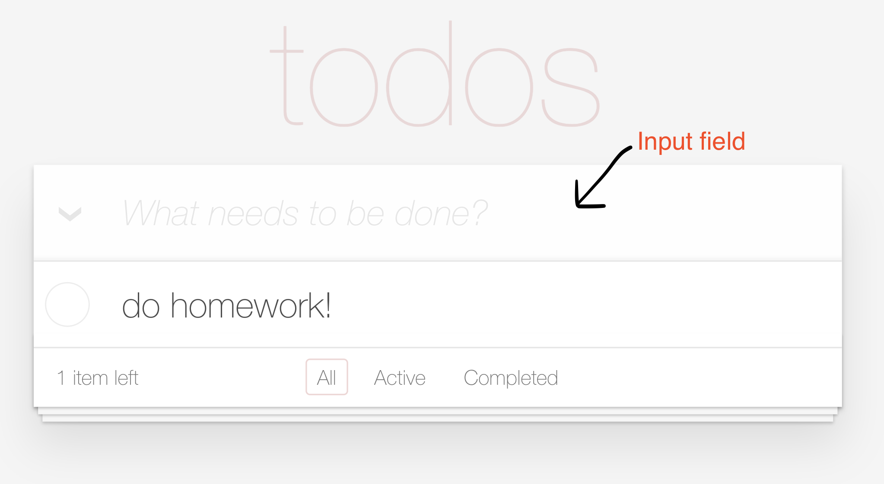

    - The status of a TODO item

There are 2 status of a TODO item: completed & active
Click the box on the left of each item to toggle between these 2 statuses.
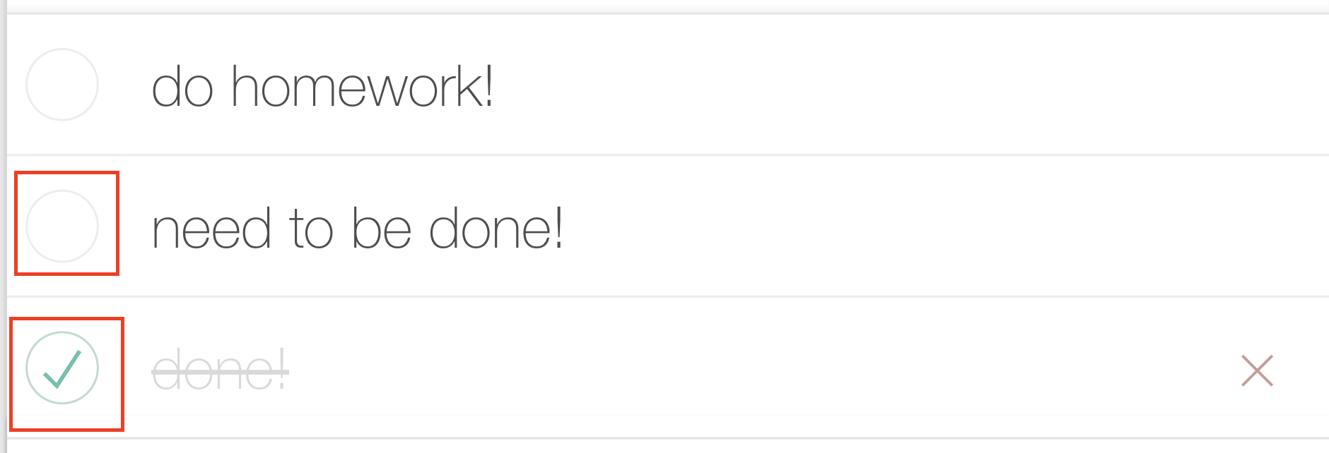
    - Remove a TODO item

when hovering the mouse over an item, a red cross sign will display on the right side of an item. Click this cross sign to delete the item.

    - Functional tab
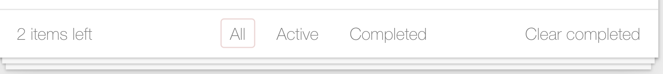
The number of items need to be done will be displayed on the left side.

To clear all completed items, click the text 'Clear completed' on the right side.

All: display all item (completed and active)

Active: only display items that need to be done.

Completed: display all completed tasks.

    - Toggle between active/ completed for all items
